­

Landsat-8 Satellite Map of Pench National Park,Madhya-Pradesh,India using Google Earth Engine and Q-GIS



Maximum Normalized Difference Vegetation Index Map of Pench National Park

2013-2018

**Technical Appendix for Report:**

**Vegetation Details of Pench National Park : NDVI Approach**

This document provides theoretical as well as technical supporting information for the Vegetation Details & Maximum Normalized Difference Vegetation Index (NDVI) report for Pench National Park in the state of Madhya-Pradesh in India.

This below technical appendix is intended to provide readers with a central repository of citations to the literature underlying the NDVI project, and to document the processes related to information quality and other technical information associated with the NDVI Project.

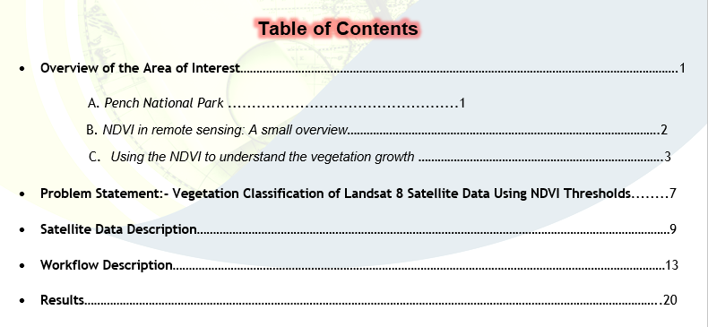

**INTRODUCTION OF THE PENCH NATIONAL PARK**

Name, Location, Constitution & Extent

# Name:

The Core area of Pench Tiger Reserve consists of Indira Priyadarsini Pench National Park and Mowgali Pench Sanctuary.

# Location:

The Indira Priyadarsini Pench National Park is located in Seoni and Chhindwara districts & The Pench Mowgali Sanctuary is confined to Kurai block of Seoni district. The buffer area includes part of Reserve and Protected Forests of South Seoni Division in Seoni district and East and South Chhindwara Divisions of Chhindwara district. The Core Area / Critical Tiger Habitat of Pench Tiger Reserve is situated at the following geographical coordinates:

|  |  |
| --- | --- |
| Longitude | 790 08' 51" to 790 31' 55" E |
| Latitude | 210 38' 55" to 210 53' 52" N |

The district wise break up of Core area is as below:

|  |  |  |  |
| --- | --- | --- | --- |
| **Status** | **District Seoni (Area in sq. km.)** | **District Chhindwara (Area in sq. km.)** | **Total (Area in sq. km.)** |
| National Park | 145.568 | 147.289 | **292.857** |
| Sanctuary | 118.473 | - | **118.473** |
| **Total** | **264.041** | **147.289** | **411.330** |

***NDVI in Remote Sensing: A small overview***

**INTRODUCTION**

Vegetation index can be used as an indicator to quantify the greenness of plants within satellite data. There are several vegetation indices, but the most frequently used index is the Normalized Difference Vegetation Index (NDVI). The normalized difference vegetation index (NDVI), which is derived from remote-sensing (satellite) data, is closely linked to drought conditions. The Normalized Difference Vegetation Index (NDVI) is a numerical indicator that uses the visible and near-infrared bands of the electromagnetic spectrum, and is adopted to analyze remote sensing measurements and assess whether the target being observed contains live green vegetation or not. To determine the density of green on a patch of land, the distinct colors (wavelengths) of visible and near-infrared sunlight reflected by the plants are observed. By analyzing images recorded from visible red and near-infrared (NIR) wavelengths, researchers can determine the coverage of vegetation on the surface of the Earth. NDVI can be expressed as (1):

|  |  |
| --- | --- |
| NDVI = (NIR – RED) / (NIR + RED) | (1) |

Where RED and NIR stand for the spectral reflectance measurements acquired in the red (visible) and near-infrared regions, respectively.

NDVI has found a wide application in vegetative studies as it has been used to estimate crop yields, pasture performance, and rangeland carrying capacities among others. It is often directly related to other ground parameters such as percent of ground cover, photosynthetic activity of the plant, surface water, leaf area index and the amount of biomass. NDVI was first used in 1973 by Rouse et al. from the Remote Sensing Centre of Texas A&M University. Generally, healthy vegetation will absorb most of the visible light that falls on it, and reflects a large portion of the near-infrared light. Unhealthy or sparse vegetation reflects more visible light and less near-infrared light. Bare soils on the other hand reflect moderately in both the red and infrared portion of the electromagnetic spectrum (Holme et al 1987). Since we know the behavior of plants across the electromagnetic spectrum, we can derive NDVI information by focusing on the satellite bands that are most sensitive to vegetation information (near-infrared and red). The bigger the difference therefore between the near-infrared and the red reflectance, the more vegetation there has to be.NDVI values are represented as a ratio ranging in value from -1 to 1. Areas of barren rock, sand, or snow usually show very low NDVI values (for example, 0.1 or less).High NDVI values (approximately 0.6 to 0.9) correspond to dense vegetation such as that found in temperate and tropical forests or crops at their peak growth stage.

In this study, we used multispectral satellite data that acquired from Landsat 8 for a vegetation classification of Pench National Park in India. A multispectral data that are used for NDVI classification is compared to the ground truth data. Supervised classification is a process where the user selects representative samples for each land cover class in the digital image. These sample land cover classes are called training data. The classification of land cover is based on the spectral signature defined in the training set. The digital image classification software determines each class on what it is similar to most in the training set. In the supervised classification, the NDVI images are categorized into certain classes according to the NDVI value. Some techniques were applied to execute the process of vegetation classification using NDVI.

**What do NDVI predict?**

* Wheat biomass (NIR) and Nitrogen uptake reliably predicted at Feekes 4 & 5 (Stone et at., 1997, Lukina et al., 2000)
* At the same stage percent ground cover and NDVI are co-related with vegetative biomass of wheat.
* Grain yield from reflectance readings of NIR and Red
  + - Important in variable rate fertilizer recommendation based on predicted yield.
    - Relationship decrease as wheat became ripened.
    - Two late season readings may give more stable prediction as compared to that of a single reading.

**RELATED WORKS**

It is important to know if the spectral features of Landsat 8 are of the same standard as previous Landsat data because Landsat 8 data have narrower bands, especially because of the normalized difference vegetation index (NDVI) calculation which is the most popular vegetation index .A technique called Normalized Difference Vegetation Index (NDVI) is used to quantify temporal Pench National Park green space dynamics ,presented with a method for a supervised classification of NDVI time series to identify vegetation type and vegetation coverage, absolute in percentage coverage or relative to a difference NDVI cycle.

Presented an improved method for the analysis of satellite image based on NDVI. The method employs the multispectral remote sensing data technique to find spectral signature of different objects such as vegetation index, land cover classification, concrete structure, road, urban areas, rocky areas and remaining areas. The study presents recent high-resolution multispectral satellite data were used to produce land use or land cover classification and NDVI mapping for the park. Many algorithms have been developed for the remote estimation of biophysical characteristics of vegetation, in terms of combinations of spectral bands, derivatives of reflectance spectra, neural networks, inversion of radiative transfer models, and several multi-spectral statistical approaches. However, the most widespread type of algorithm used is the mathematical combination of visible and near-infrared reflectance bands, in the form of spectral vegetation indices. The general objective of this study is to evaluate NDVI vegetation indices for the remote estimation of the green area index for Pench National Park in India.

**MATERIALS AND METHODS**

**Data**

This area is located between longitudes 790 08' 51" to 790 31' 55" E and latitude210 38' 55" to 210 53' 52" N. The satellite data were acquired from USGS Landsat 8 data that are used in this study. The data were selected based on the high quality of data acquired by the Landsat satellite.By using spectral subset in Google Earth Engine. The selected regions of interest (ROI) were chosen as training pixels. The file contains with the 871 pixels × 1007 pixels.

***Classification***

Before the classification, the process was begun with image enhancement by using a decor relation stretch to enhance the image for more effective visualization. Figure 1 shows the flow chart of classification and accuracy assessment process for this study. Afterwards, the experiment was continued by computing the NDVI. In this study, different combination bands of 5-4-3 (NIR, Red, and Green) are constructed to red, green and blue (RGB color). The RGB image is a standard color for/of infrared (CIR) image. The NDVI was determined using (2):



The experiment continued to locate the vegetation by setting the threshold of NDVI image. The values of NDVI threshold are shown in Table 1.

**Table 1**

**NDVI Values**

|  |  |
| --- | --- |
| **Value of NDVI** | **Descriptions** |
| 0.46 or less | low NDVI |
| 0.46 to 0.60 | Moderate NDVI |
| 0.6 to 0.9 | High NDVI |

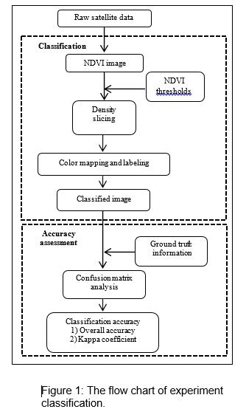

The training data are divided into 3 major classes: Water, Rock or Sand area, Non-vegetation and Vegetation area. The results are recorded. Density slicing is a process where the NDVI are set as a modified gray level image. Afterwards, the color mapping and labeling of the satellite image for three classes are performed. The process of classification based on NDVI threshold is explained and compared to the classified image with the ground truth.

***Accuracy assessment (Confusion matrix)***

The information of ground truth data is compared to the classified image in order to check the accuracy. The accuracy of user and producer are carried out to measure the classification accuracy. Producer’s accuracy is where the individual class accuracy can be acquired by dividing the sum of correctly classified pixels.. Meanwhile, the user’s accuracy is a measurement where the individual class acquired from the classified pixels in same group .The overall accuracy is calculated based on the confusion matrix that obtained for user’s accuracy and producer’s accuracy. The description of overall accuracy is shown below:



Kappa coefficient (4) is another measurement to measure the training pixels with the ground truth data. The Kappa values are +1.0 to -1.0 to measure where the positive value shows high accuracy. A value of zero shows no correlation in classification.



where:

= total number of pixels



= number of classes

= total number elements of confusion matrix

= sum of row 

= sum of column 

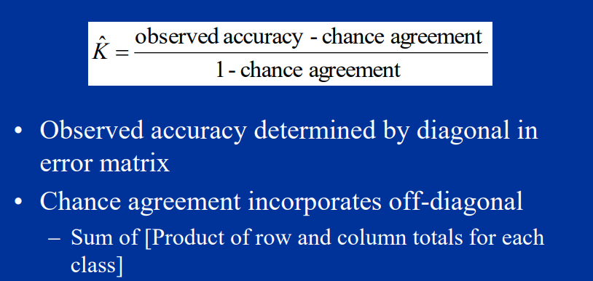



Kappa,the coefficient of agreement values should lie between -1 to 1 as per the above picture.

**Limitation of NDVI**

* It can only measure the surface vegetation biomass at late growth stages.
* It can only read in 2 dimensional field.
* It can not predict the amount of nitrogen concentration in the plant.

**Problem Statement:- Vegetation Classification of Landsat 8 Satellite Data Using NDVI Threshold**

This study aims to classify Landsat 8 satellite data for Pench National Park located in Madhya Pradesh in India using NDVI thresholds for the period of 2013 to 2018. Initially, visible and near infrared bands of Landsat 8 satellite were used to derive Normalized Different Vegetation Index (NDVI) image. Vegetation, non-vegetation areas were then analyzed where thresholds for separating them are carefully determined with the aid of ground truth information of the study area. Density slicing was performed in order to separate the image into different land covers. Eventually, color mapping and class labeling were done to complete the classification process. The accuracy of the classified image is then assessed using a confusion matrix where overall classification accuracy and Kappa coefficient are computed. The result shows that NDVI-based classification is able to classify the Landsat 8 satellite data with a high accuracy.

*Index Terms*—Accuracy Assessment, Multispectral, NDVI Supervised, Threshold, Vegetation.

Though we often take the plants and trees around us for granted, almost every aspect of our lives depends upon them. They feed us, clothe us, absorb carbon dioxide, provide us with oxygen, and give us building materials and medications. When drastic changes occur to the vegetation around us, our health, economy, and environment are all affected. Twenty-five years ago, for instance, thousands of people starved when the vegetation in the Sahel region of Africa dried up during an extended drought. Over the past five decades deforestation in South America has left thousands of acres fallow and has destroyed many species including possible valuable medications.

In an effort to monitor major fluctuations in vegetation and understand how they affect the environment, 20 years ago Earth scientists began using satellite remote sensors to measure and map the density of green vegetation over the Earth. Using NOAA’s Advanced Very High Resolution Radiometer (AVHRR), scientists have been collecting images of our planet’s surface. By carefully measuring the wavelengths and intensity of visible and near-infrared light reflected by the land surface back up into space, scientists use an algorithm called a "Vegetation Index" to quantify the concentrations of green leaf vegetation around the globe. Then by combining the daily Vegetation Indices into 8-, 16-, or 30-day composites, scientists create detailed maps of the Earth’s green vegetation density that identify where plants are thriving and where they are under stress (i.e., due to lack of water).

Satellite imagery has a number of advantages. It can be used to track weather systems, especially dangerous storms like hurricanes, with great accuracy. Satellites circle the Earth, so their imaging activity can be repeated easily. It also allows for much greater areas of coverage and, because all information is digital, it can be easily integrated with software. In some cases, cloud cover does not affect results.

**Satellite Data Description**

**Landsat 8 at a glance**

**•**The Landsat 8 program, jointly managed by NASA and the USGS, provides satellite data that is in the public domain and free.

**•**Landsat 8 became fully operational on April 11, 2013.

**•**The satellite orbits Earth every 99 minutes at an altitude of 705 kilometers (438 miles) in a polar orbit. The satellite records the daylight side of Earth on the soutbound leg of its orbit.

**•**Landsat 8 collects about 400 new scenes comprising 400 GB of data every day. Processed data becomes available to the public within 24 hours of collection.

**•**Despite voluminous data collection, it will take several years before cloud-free scenes are available for most areas. Obtaining cloud-free images of some very wet tropical areas may never happen.

**•**Regular coverage includes the area between 82° 40' north and south latitude. Off-nadir (sideways looking) scenes extend coverage to slightly higher latitudes, but not as far as the poles.

**•**The satellite returns to the same place on Earth occur every 16 days and at the same time of day. It records new scenes depending on the weather below and other collection requirements.

**•**The mid morning hours are when the satellite records scenes everywhere on Earth. It crosses the equator at around 10:00 AM.

**•**Scenes are north-oriented. However, because Earth rotates east as the southbound satellite flies over it, the area covered in scenes follows the northeast to southwest trending flight paths.

• Along flight path axes, Landsat 8 scenes measure 185 kilometers wide by 170 kilometers tall (115 x 105 miles).

**•** Landsat 8 does not take photographs. Rather the satellite's two sensors collect data from discrete portions of the electromagnetic spectrum known as bands and determined by their wavelength. There are 11 bands. Some of the bands represent portions of the electromagnetic spectrum invisible to the human eye.

• Landsat 8 scenes are georeferenced and orthorectified to elevation data. They are in the UTM/WGS 84 coordinate system.

**•**Downloaded Landsat 8 bands come as 16-bit grayscale geotifs, which are ordinary .tif images, but with extra georeferencing information. Note that the satellite sensors collect raw data at the 12-bit depth. Interpolation accounts for the greater bit-depth of the released data.

**•**The ground resolution (how much distance each pixel represents on Earth) of the bands is generally 30 meters. Band 8 containing panchromatic data at 15-meter resolution is an important exception. Bands 10 and 11 are upsampled to 30-meter resolution from data collected at 100-meter resolution.

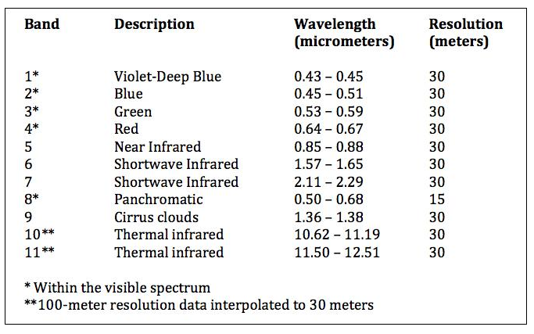

## **Workflow Description**

We created the satellite image of the protected area of Pench National Park in Madhya Pradesh, India using Google Earth Engine and then we have put the satellite image in Q-GIS to produce the NDVI vegetation map of Pench National Park,Madhya-Pradesh,India. Below is the step by step guide of the procedure of creating the satellite landsat 8 image to finishing a digital map using Q-GIS software.

**Google Earth Engine Steps**

One of the latest application launched by Google is **Google Earth Engine**, an advanced **cloud-based** geospatial processing platform, designed mainly for planetary-scale environmental data analysis. It combines a multi-petabyte catalog of satellite imagery and geospatial datasets, which allow users to **visualize**, **manipulate**, **edit** and **create** spatial data in an easy and fast way. It incorporates a wide range of spatial manipulation tools which allows scientists, researchers, and developers to **detect changes**, **map trends**, and**quantify differences** on the Earth’s surface.

The ability to **analyze** and**manipulate** data according to users needs, differentiate this application from the traditional Google Earth.

**Earth Engine** stores, more than thirty years of historical imagery and scientific datasets, updated and expanded daily. It organizes them and make them available for public users, as well as, for commercial ones or administrations systems.

Other capabilities include:

* Integration with Python and JavaScript through its API. APIs for JavaScript and Python (hosted on GitHub) for making requests to the Earth Engine servers. These docs focus on JavaScript; (Get started guide for the Javascript API).
* Use our **web-based code editor** for fast, interactive algorithm development with instant access to petabytes of data. **Code Editor:** An online Integrated Development Environment (IDE) for rapid prototyping and visualization of complex spatial analyses using the Javascript API. Exlore the Code Editor docs.

To work with the application it is necessary to register as a user, for that you have to click on the “Sign up” button.After your registration will be completed you can access the platform which and start exploring its capabilities. For example load different types of satellite images already processed.

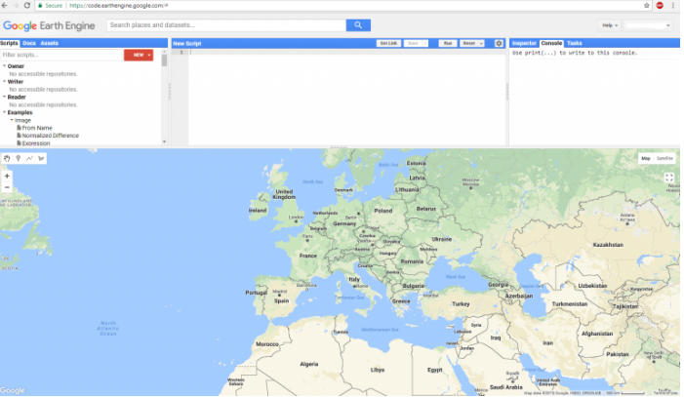

Now we can start working with the google earth engine to create satellite image of our desired protected area. First ,we write the code in the above blank window. Below is a screenshot of the code we have written to fetch the protected area satellite image of Pench National Park in Madhya Pradesh ,India and calculate respective Normalized Difference Vegetation Index for the time period 2013-2018 to study vegetation. We used near Infrared band as band 5 and Red as band 4 in order to calculate the NDVI Index.



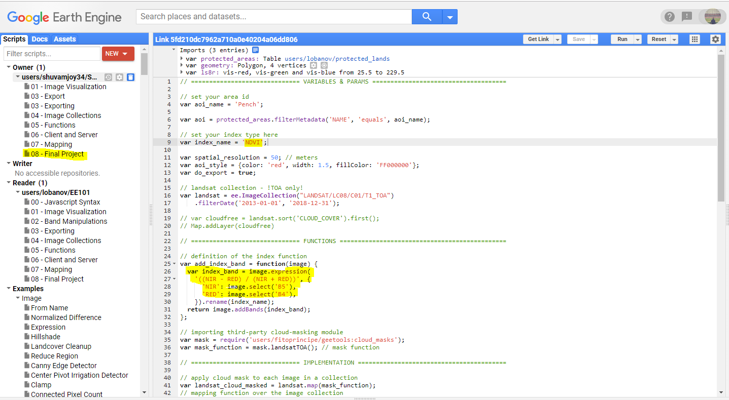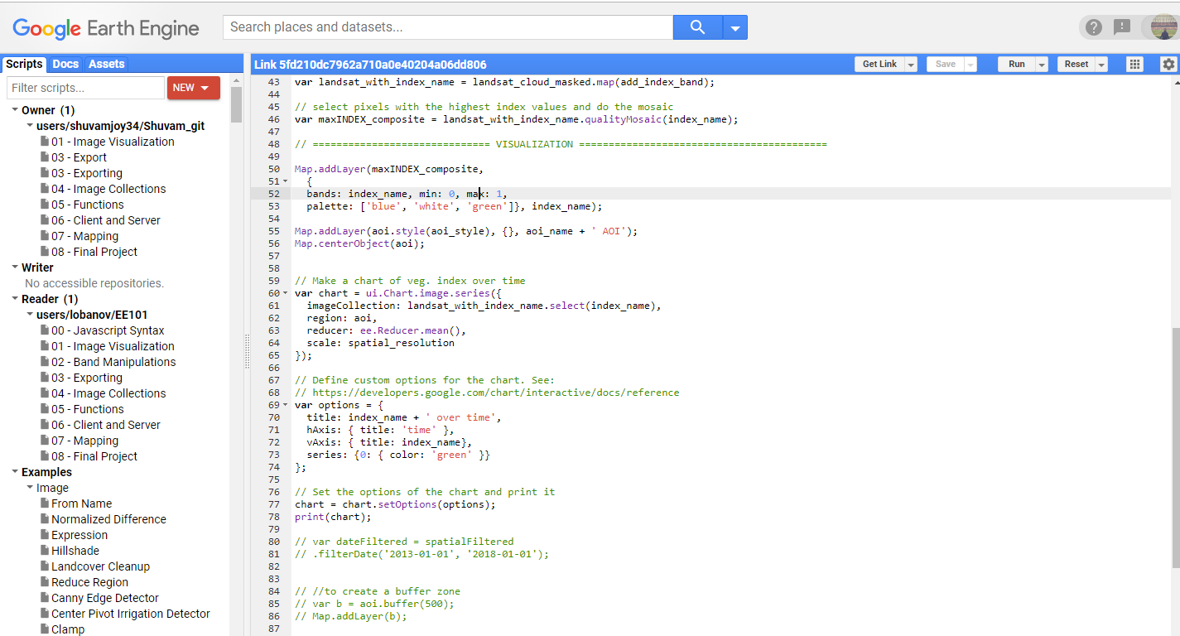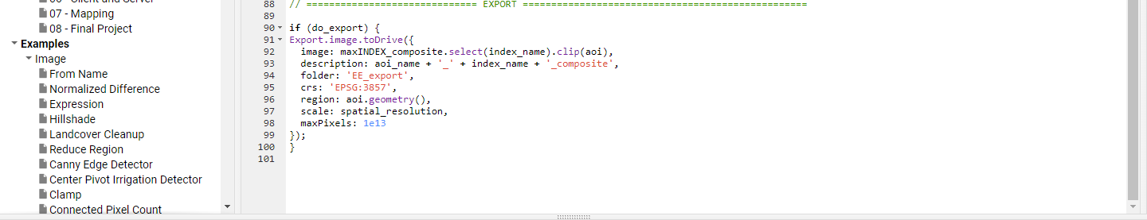

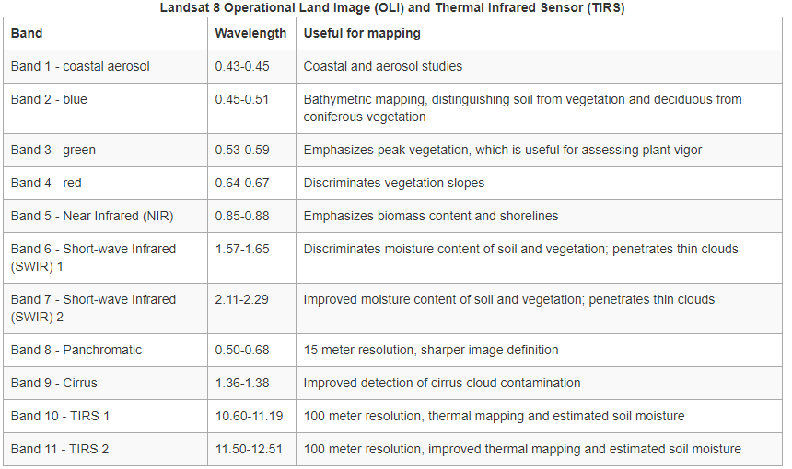

Since we are studying the vegetation here , so we have used band 4 and band 5 here explained already in the above picture . Now after running this code, we get the satellite image of the protected area of Pench National Park.

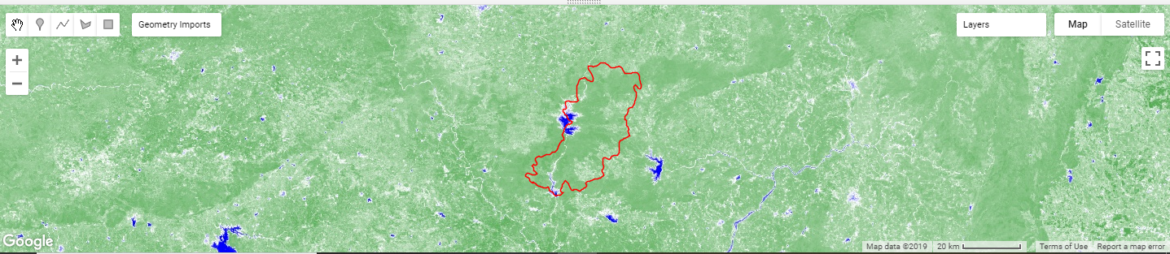

After this, we go to console tab and save the NDVI graph that got generated. Also in the task bar , we run the recently generated satellite NDVI image of Pench National Park and save it in our own respective google drive.

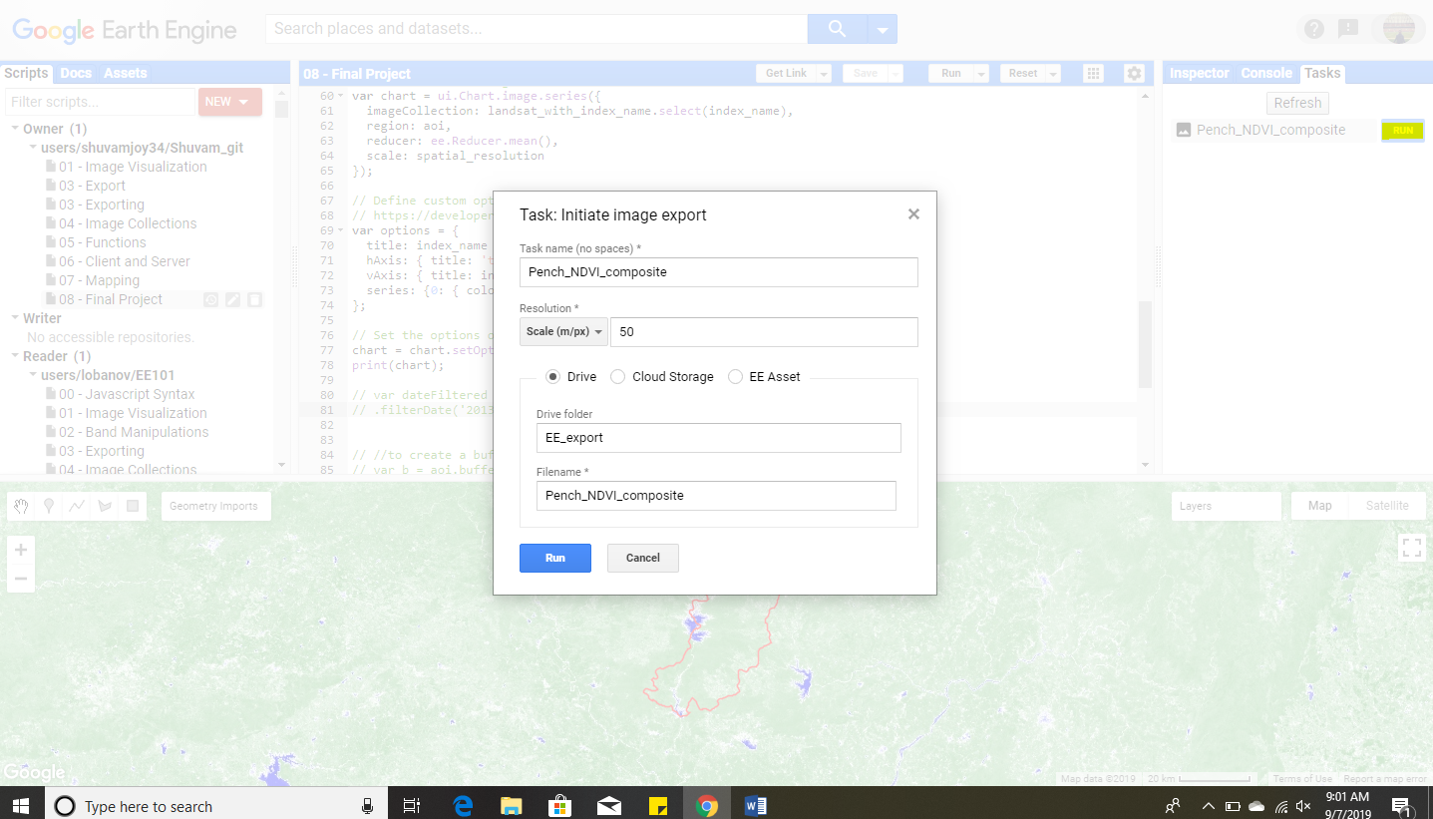

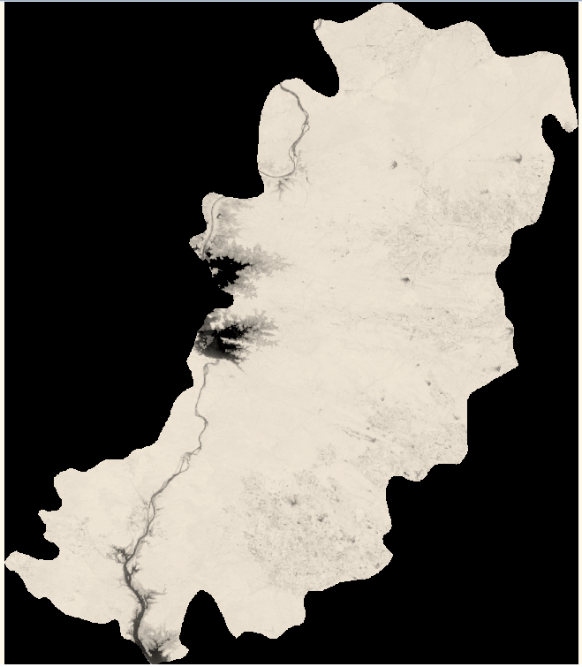

Q-GIS steps of creating the digital NDVI vegetation map of Pench National Park

First install the Q-GIS software 3.4 version in our computer and open it . Then drag and drop the satellite image of Pench National Park, you downloaded from google earth engine in tif format from your google drive to Q-GIS and save it with the name Pench NDVI Composite.Now double click on the map layer and select the layer properties according to the below screenshot.

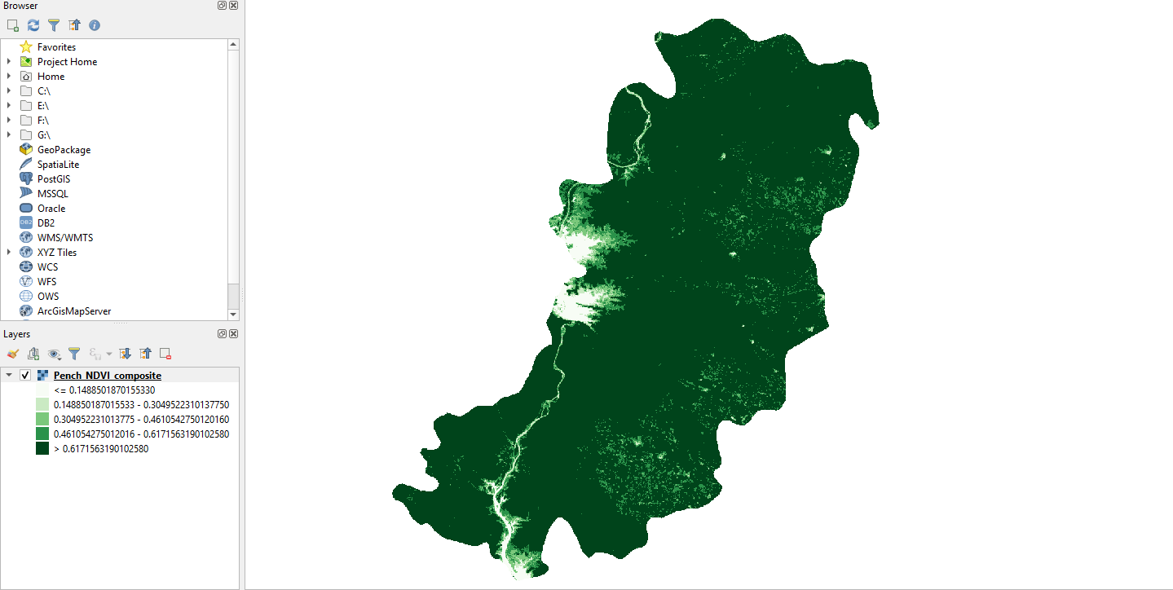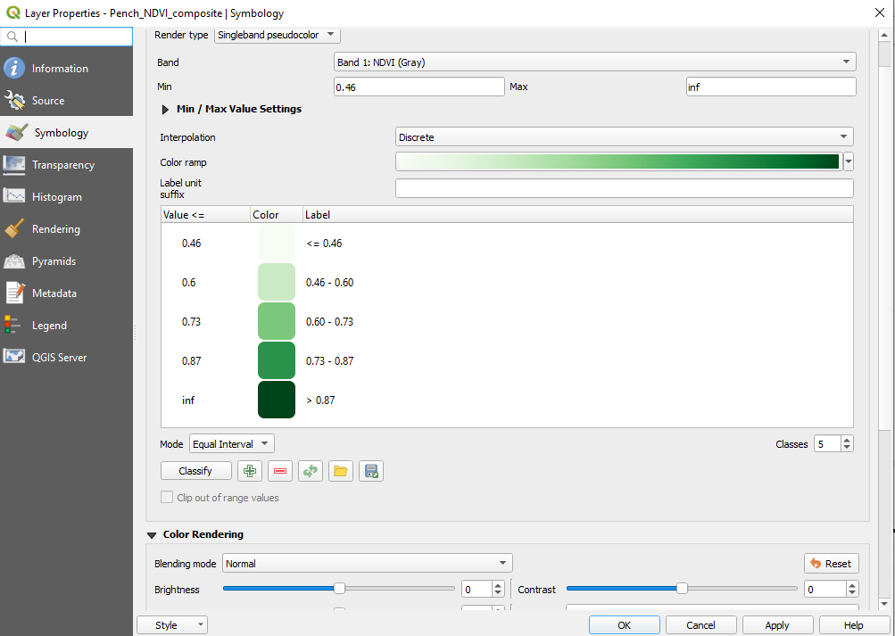

In the Min/Max Value setting , select cumulative count cut to represent the vegetation areas in the map in better way.Post that, adjust the label unit values to avoid unnecessary large numbers.(Keep it upto two decimal places).Now change the layer name as NDVI Values. Now go to project and the click on new print layout. Give a name of the map you are going to create (For our case it will be NDVI Pench).You will end up landing in a new map creating page like below:-

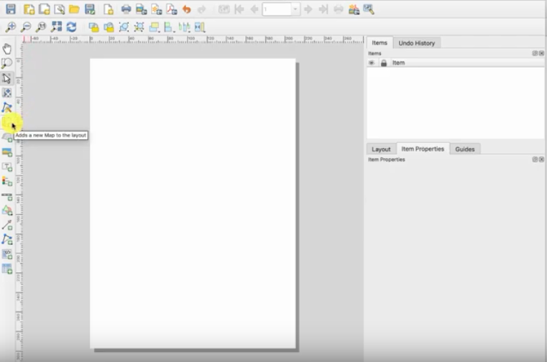

Now click on add a new map and the satellite image of pench national park attached above will come here.Page orientation should be potrait and the size of the paper would be A4.For title front of the map use Arial and for subtitle front of the map use times new roman. So add title and subtitle for the map.Now create a grid for the map. Click on the map, click on grid ,add a grid , change the CRS to WGS84. Then adjust the interval( for our case aprroximately 0.200000 degrees,front style shoud be in line border.Now go to draw co ordinate and adjust the unit according to the map you are creating.(For our case it is in degree and minute format) and change co ordinate precision to zero. Keep all the front simalteneously same while working on the map creating.(For our case it is Times new roman and size would be 11). Now add a scale bar and go to the settings of the scale bar.Change the fixed width to 5 unit and put the scale bar of 10 Kilometer distance inside the co ordinates.Now add a box below the map which will include all additional descriptions related to the map which includes the NDVI compositions, legends,boundaries of India,description of NDVI Index ,data source,map projection ,author name and date of creation of the map. Now using add a new picture, insert the RUDN university logo and resize it accordingly.Now using move item content option, adjust the co ordinates according to the map so that the raster would fit the map window.Now go to the scale bar and select the option fronts and colors. Then under that option, select draw the buffer option and drag the scale bar on the map and you will see a buffe zone is getting created.

Now create an overview map. To create that, switch to Q-GIS window. Before that, go to the map and click on lock layer option so that even if we add an overview map of Indian territory ,the map will not get afftected.Now drag and drop the geo package file of Indian boundary on Q-GIS project window and then select IND 1 layer and label as Name 1. It will show all the states name separately on the Indian geographical boundary. Now go to the map again and import the boundary using add a new map option. Now to highlight the actual area of Pench National Park in that Indian geographical boundary we will change the color of the point shown our focus area to some darker color as well as will zoom in the Indian boundary to focus on that particular area of Pench National Park only.Also, if possible just go to frame option and activate the frame around the boundary. Now our digital NDVI Vegetation Index Map of Pench National Park in ready to be exported and downloaded as PDF.

Confusion Matrix Steps and procedure

Now to check the accuracy, we can check the confusion matrix by using the **Confusion Matrix Using Ground Truth Image** and **Confusion Matrix Using Ground Truth ROIs** tools to calculate confusion matrices and accuracy metrics. Below is a short example and procedures step by step of how can we calculate the confusion matrix and cross check the accuracy level of the information we got about NDVIs and green vegetation about Pench National Park in Madhya Pradesh,India.

## **Use a Ground Truth Image**

When using a ground truth image, you can also calculate error mask images for each class showing which pixels were incorrectly classified.

**Note:**The ground truth image and input image must have the same X and Y dimensions, pixel sizes, and spatial reference so that their pixels exactly align.

* From the Toolbox, select **Classification > Post Classification > Confusion Matrix Using Ground Truth Image**. The Classification Input File dialog appears.
* Select an input file and perform optional spatial and spectral subsetting, then click **OK**. The Input File dialog appears. The Ground Truth Input File dialog appears.
* Select the ground truth image and perform any spatial subsetting, then click **OK**. The Match Classes Parameters dialog appears.
* Match the ground truth classes with the classification result classes by selecting the matching names in the two lists and clicking **Add Combination**. The class combinations are shown in a list at the bottom of the dialog. If the ground truth and classification classes have the same names, they are automatically matched.
* To remove a class match from the list, select the combination name. The two class names reappear in the lists at the top of the dialog.
* Click **OK**. The Confusion Matrix Parameters dialog appears.
* Next to the **Output Confusion Matrix in** label, select the **Pixels** and/or the **Percent** check boxes. If you select both check boxes, they will be reported in the same window.
* Next to the **Report Accuracy Assessment** label, select the **Yes** or **No** toggle.
* Next to **Output Error Images** label, click the toggle button to select **Yes** or **No**.
* The output error images are mask images, one for each class, where all correctly classified pixels have a value of 0 and incorrectly classified pixels have a value of 1. The last error image band shows all the incorrectly classified pixels for all the classes combined.
* Select output to **File** or **Memory**. If **File** is selected, enter an output filename.
* Click **OK**.

## **Use Ground Truth Regions of Interest**

You can display a confusion matrix using ROIs for ground truth. This report pairs ROIs with the classes of a classification image to show what percentage of the ROI pixels were or were not contained in a resulting class. To display a confusion matrix report using ROIs for ground truth:

* From the Toolbox, select **Classification > Post Classification > Confusion Matrix Using Ground Truth ROIs**. The Classification Input File dialog appears.
* Select a classification input file and perform optional spatial and spectral subsetting, then click **OK**. The Ground Truth Input File dialog appears. The Match Classes Parameters dialog appears.
* Match the ground truth ROIs with the classification result classes by selecting the matching names in the two lists and clicking **Add Combination**. The class combinations are shown in a list at the bottom of the dialog. If the ground truth and classification classes have the same names, they are automatically matched.
* To remove a class match from the list, select the combination name. The two class names reappear in the lists at the top of the dialog.
* Click **OK**. The Confusion Matrix Parameters dialog appears.
* Select the **Pixels** and/or the **Percent** check boxes.
* Click the **Yes** or **No** toggle for **Report Accuracy Assessment**, and click **OK.**

## **Confusion Matrix Example**

In an NDVI confusion matrix, columns represent true classes, while rows represent the classifier's predictions. The matrix is square, with all correct classifications along the upper-left to lower-right diagonal. Below is just an example of a Confusion matrix using random numbers and headers.

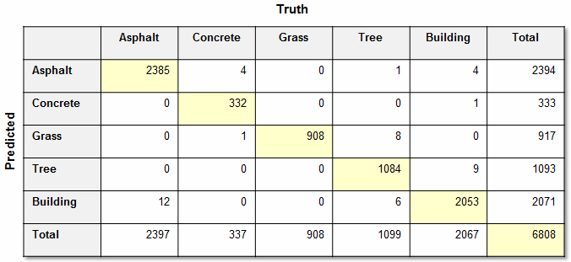

Here are some examples of how to read this matrix:

* 2,385 values were correctly classified as Asphalt.
* Reading down the Concrete column, 4 values that should have been Concrete were classified as Asphalt, and 1 value was classified as Grass. These are *omission errors*, which are defined as the fraction of values that belong to a class but were predicted to be in a different class. Errors of omission represent false negatives.
* Reading across the Concrete row, 1 value that should have been Building was classified as Concrete. This is a *commission error*, which is defined as the fraction of values that were predicted to be in a class but do not belong to that class. Errors of commission represent false positives.
* This confusion matrix example is based on the number of *pixels.*
* The row and column headers are the classes.

### **Overall Accuracy**

The *overall accuracy* is calculated by summing the number of correctly classified values and dividing by the total number of values. The correctly classified values are located along the upper-left to lower-right diagonal of the confusion matrix. The total number of values is the number of values in either the truth or predicted-value arrays.

In the example confusion matrix, the overall accuracy is computed as follows:

**Correctly classified values**: 2385 + 332 + 908 + 1084 + 2053 = 6762

**Total number of values**: 6808

**Overall accuracy**: 6762 / 6808 = 0.993243

To read the accuracy measure above for example,the overall classification accuracy for the image provided equals nearly 99%. E.g. about 99% of pixels are correctly assigned, and 6% of pixels are assigned with errors. That means, , This is quite a high accuracy.

### **Errors of Commission**

*Errors of commission* represent the fraction of values that were predicted to be in a class but do not belong to that class. They are a measure of false positives. Errors of commission are shown in the rows of the confusion matrix, except for the values along the diagonal.

In the example confusion matrix, the errors of commission are computed as follows:

**Asphalt**: (4 + 0 + 1 + 4) / 2394 = 0.0038

### **Producer Accuracy**

*Producer accuracy* is the probability that a value in a given class was classified correctly. In the example confusion matrix, producer accuracy is computed as follows:

In the example confusion matrix, producer accuracy is computed as follows:

**Asphalt**: 2385 / 2397 = 0.995

### **User Accuracy**

*User accuracy* is the probability that a value predicted to be in a certain class really is that class. The probability is based on the fraction of correctly predicted values to the total number of values predicted to be in a class.

In the example confusion matrix, user accuracy is computed as follows:

**Asphalt**: 2385 / 2394 = 0.996

So using the exactly same procedure , we can also check the accuracy level of our map presentation of Pench National Park,Madhya-Pradesh,India.

**Result**

After downloading the map and saving it in PDF format, the final presentable map will look like below:-

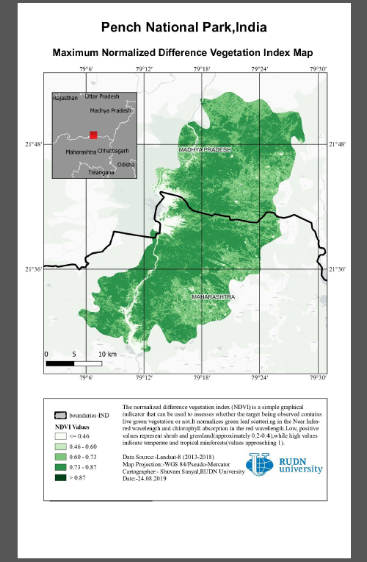

Now we have to analyze the result and from the results and steps we can visualize some findings in this map regarding vegetation based on NDVI values. Also we can check the procedure to check our accuracy of pixel classification using confusion matrix. Now from Google Earth Engine, we already got the list of NDVI values for the Pench National Park for the time period 2013-2018.

According to the definition, NDVI values are represented as a ratio ranging in value from -1 to 1. Areas of barren rock, sand, or snow usually show very low NDVI values (for example, 0.1 or less).High NDVI values (approximately 0.6 to 0.9) correspond to dense vegetation such as that found in temperate and tropical forests or crops at their peak growth stage.

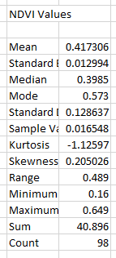

Now from the above two pictures we can see that NDVI values do not cross 0.6 much with minimum NDVI being 0.16,average NDVI being 0.417,median NDVI being 0.3985 and highest NDVI being 0.649.

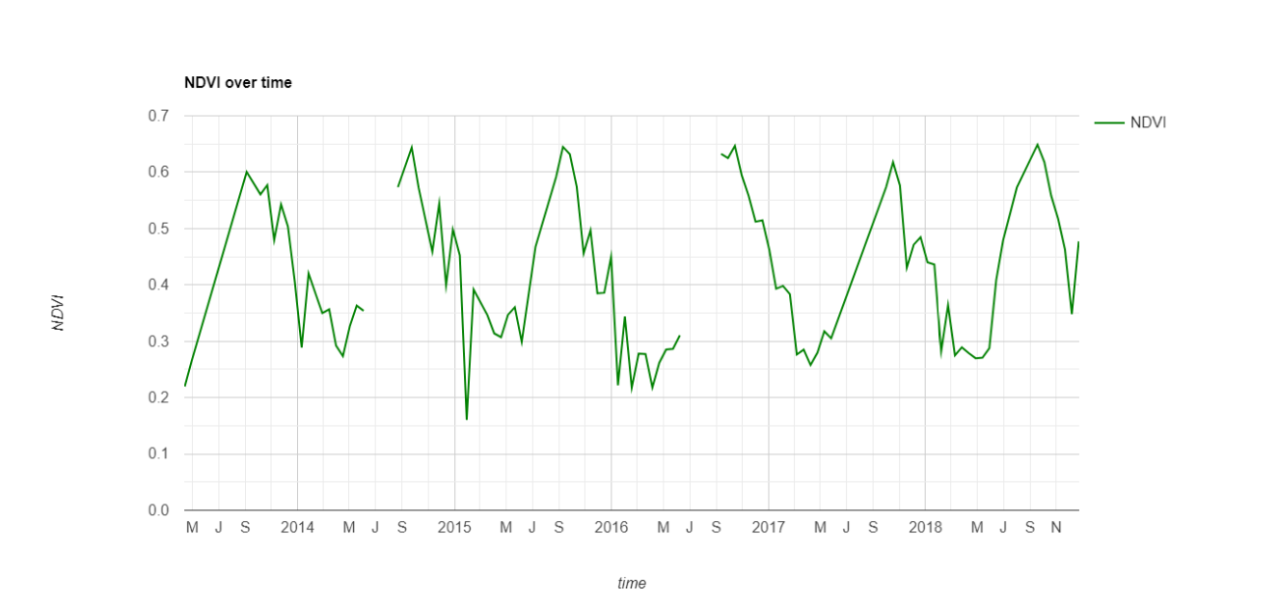

So overall we can conclude that on an average , we have medium level of vegetation in Pench National Park ,Madhya Pradesh,India with a trend of decreasing green vegetation quite frequently (NDVI Values less than 0.46 getting repeated the maximum times )seeing at the NDVI values table and the graph over time. This is not a good sign for any national park and some proper actions need to be taken to increase the level of green vegetation so that continuous decreasing trend of green vegentation can not affect the animals living peacefully as well as the overall well being of climate in the Pench National Park in negative ways.

Experience of using Landsat satellite imagery to create the NDVI vegetation map of Pench National Park,Madhya Pradesh,India has been great too. Satellite images are like maps: they are full of useful and interesting information, provided you have a key. They can show us how much a city has changed, how well our crops are growing, where a fire is burning, or when a storm is coming. To unlock the rich information in a satellite image, you need to:

1. Look for a scale.
2. Look for patterns, shapes, and textures.
3. Define the colors (including shadows).
4. Find north.
5. Consider your prior knowledge.

Landsat satellite imagery can be used in land use and mapping,geology,hyderology,costal resources as well as environmental monitoring.

As we have seen there is a trend of low NDVI values and decreasing green vegetation area around the Pench National Park in India from 2013 to 2018, I have some recommendations on application of the workflow to solve similar vegetation problem in India as well as some suggestions below:-

* Retain what is left and manage it properly.
* Before starting restoration, address the factors that limit natural regeneration because these will also limit any planting.
* Consider how large-scale plantings can increase linkages between native habitats, plus the total area of native habitat, and how they'll enhance all-year round food supplies for local fauna.
* Eco-source an ecologically appropriate range of plant species and mycorrhizal fungi.
* Establish certification for seed and seedling supply.
* Invest in new technologies for revegetation, especially for steep, inaccessible hill country.
* Adopt best-practice planting and early management, including appropriate monitoring, to ensure the long-term success of [restoration](https://phys.org/tags/restoration/).
* Integrate all areas of native vegetation – for example public, private, old growth, regenerating and planted – for an optimum result.

